Linux Essentials Project:
This is the project for Linux Essentials Course. You must perform a total of 4 tasks to complete this project. Please note that you will be required to answer a few questions while doing this project and will be asked to take screenshots where necessary. Make sure that you take these screenshots and save them on your local machine, we will ask you to provide the answers and screenshots for project grading purposes.
Task # 1: Installation of Ubuntu OS in VMware workstation
Requirements:
In this task you will install Ubuntu OS in a virtual machine that you will create in VMWare Workstation. You need to submit screenshots of the steps that you follow for installation and the final screenshot of ubuntu after installation. (No need to share the screenshots of VM creation)
Resources:
Below are the resources you need while you are performing this task:
• VMWare Workstation Software (click the link below to download this software) o https://www.vmware.com/products/workstation-pro/workstation-pro-evaluation.html • Product key to activate VMWare Workstation:
o MC60H-DWHD5-H80U9-6V85M-8280D (You can use this Key or other one)
o 4A4RR-813DK-M81A9-4U35H-06KND
• Download ISO image from below link:
o https://ubuntu.com/download/desktop
Task # 1.1: Installation of VMWare Workstation in our computer:
Step # 1: Download VMWare Workstation Software from above mention link.
Step # 2: Install it by using following instructions:
• Double Click on the Software VMWare Workstation 17 pro.
• Click Next to start the installation.
• Accept the License Term and Click on Next.
• Now Enable Both Options that are mentioned in this step and Press Next.
• Enhanced Keyboard Drivers (a reboot will be required to use this feature).
• Add VMWare Workstation console tools into system Path.
• Here, you can remove the checks in User Experience Settings and Click Next. If you need a shortcut on desktop then enable it or leave as default and Click Next.
Now, Setup is ready to install please Click on Install to begin the setup. (TAKE A SCREENSHOT OF THE INSTALLING PROCESS FOR PROJECT GRADING)
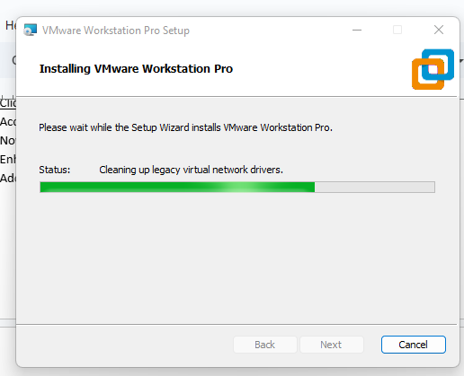
• Once it is complete do not Finish the setup Click on License and Enter the License which is provided in this manual and then activate it and reboot the machine.
• Your Step is Complete Successfully.
Congrats you have completed the installation of Virtualization Software in your computer now it’s time to move towards the next task where we will create a Virtual Machine in which we will install Ubuntu OS.
Task # 1.2: Creation of Virtual Machine in VMWare Workstation.
Now in this task we will create a Virtual Machine by following below steps:
Step # 1: Open VMWare Workstation software and perform below actions:
• Open VMWare WorkStation Software
• Click on Create New Virtual Machine
• Now the Setup Wizard is start where you have to complete all instructions.
• Now Select the option “Custom (Advance)” and Click on Next.
• Now in this Window Click Next because it just guides you on how capable this software is. • At this point select the option “I will install the Operating System Later” and Click Next. • Now at this point we need to choose the Guest Operating System. Select Linux and from the dropdown menu Select Ubuntu and then Click Next.
• Now it’s time to set the Name of your Virtual Machine; set any name for your VM and Click Next.
• Now assign the Number of Processors to your VM Select 1 in both options and Click Next. • In this step assign Memory to your VM if you have good memory in your system then do assign 4 GB at least which is (4096 MB) but if you have less memory in your computer then you can assign 2 GB (2048 MB) and then Click Next.
• Now we are configuring Network settings for our VM here you need to select “Use Network Address Translation (NAT)” and Click on Next.
• Click Next on I/O Controllers with default settings.
• Select the SCSI Storage option which is recommended and Click Next.
• Now Create New Virtual Disk by selecting the option “Create a New Virtual Disk” and Click Next.
• Now set Virtual Disk size from 20 GB to 40 GB and Select the option “Store Virtual Disk in a Single File” and Click Next.
• Now at this point it shows you the name of your Hard Disk which is usually the same as your VM so just Click Next.
• Now at the final stage, this window shows you the summary of your VM Configuration so there is no need to change anything. TAKE A SCREENSHOT OF THIS STEP FOR PROJECT GRADING and then Click on Finish.
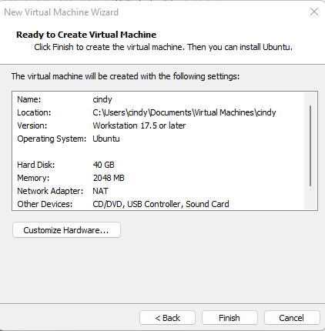
Congrats you have completed another task by creating a new Virtual Machine. Now it’s time to connect the ISO Image of Ubuntu OS in this VM.
• Click on “Edit VM Settings”.
• Select CD/DVD Drive.
• Now Select “Use ISO Image File” and Click on Browse.
• Select the Location where you have downloaded the ISO Image of Ubuntu OS select that image and Click on Open and Press OK.
You have successfully created Virtual Machine and connected the ISO image in it, now your next task is to install Ubuntu OS in this Virtual Machine.
Deliverables of Task 1
• Take screenshot of installation in progress on Task 1.1
• Take a screenshot of window that shows you the summary of your VM Configuration in Task 1.2
Task # 2: Installation of Ubuntu OS in VM
After successfully creation of VM in VMWare Workstation it’s time to install the OS and for this please complete below instructions / steps:
Instructions:
In your VMWare Workstation select your newly created machine and follow the instructions:
• Click on “Power on This Virtual Machine”
• Now Setup begins, click on the main screen and use arrow keys to Select “Try or Install Ubuntu” and Press Enter.
• Now you can see the Ubuntu Logo on your screen.
• Now on Install Window, Select Your Language and Click on “Install Ubuntu” • After selecting the “Install Ubuntu” option it ask you to add keyboard layout if you need otherwise you can go with default setting which is set for English (US) Click on Continue.
• Now at Update and Software page select below options:
o Normal Installation
o Download updated while installing Ubuntu
o Install 3rd party software for graphics and Wi-Fi hardware and additional media format. • Once you select the above mentioned options just Click on Continue.
• Now at this point it asks you to install Ubuntu here you need to select this option and Click on Install Now.
o Erase Disk and Install Ubuntu
• Now it informs you which Hard Drive the OS will install and how the Partition scheme will look like Click on Continue.
• At this point it asks you to Set your Location. Once you select it then Click on Continue. • At this point, setup ask you to enter Admin user details that include:
o Username
o Password
o Computer Name
o NickName
o And Login method
o Set all the details as per your understanding and Click on Continue
• Now, your setup has started just sit back and enjoy the time.

• Once all files install successfully it asks you to Restart your machine just restart it and complete your installation.
• Enter your User’s name and Password to login (TAKE A SCREENSHOT OF THIS STEP FOR PROJECT GRADING)
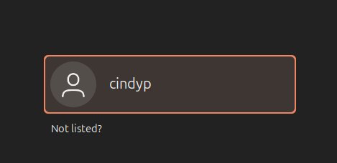
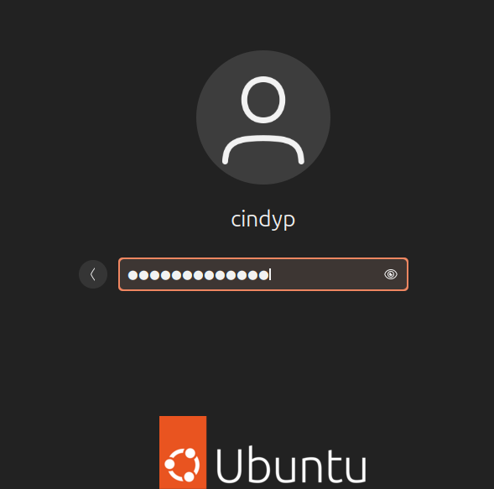
• Now it asks you to complete some basic settings for your OS. Use below options: o Click on Skip on Top Right Corner of the Online Account Tab
o Click Next on Top Right Corner of the Live Patch
o Click Next on Top Right Corner of the Help Improve Ubuntu Page
o Click Next on Top Right Corner of the Privacy Page
o Click Done on Top Right Corner of the Software Page
That’s it your Ubuntu Virtual Machine is now ready to use. And here your task is complete.
Deliverables of Task 2:
• Take a screenshot of the login screen of Ubuntu where you need to enter the username and password.
Task # 3: Working in Terminal
In this task you will work in a command line environment where you generate output of your commands for different activities.
Exercise # 1: Working with ls command:
In this exercise you will share results of some ls commands that how those commands look like: Instructions:
For completing this task, you need Terminal Console which you can start by clicking on 9 square dots which are placed in your Ubuntu Screen at the left bottom corner. Just click on those 9 dots and then click on the terminal. Your terminal is on now.
At this point you will see this image:

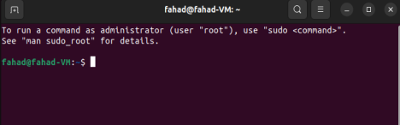Now please write the name of the options you see in this console:
cindyp@ = cindyp-
cindyp-VM = ware-Virtual-Platform:
~ = $
cindyp@cindyp-VMware-Virtual-Platform:~$
After this please answer the following question.
• What is meant by ls command and how do we use it? Provide at least 3 tasks that you can perform with ls command.
The ls command stands for ‘lists’. The ls command lists the current directories and files. The ls command is used to navigate files from the terminal, it helps to check details about the file, and it shows what’s in the directory.
The three tasks that I can perform with the ls command are:
- ls -a
- ls -l
- ls -lt
Each of these tasks navigate directories and files within the terminal. The first command, ls -a, lists all the files and also lists hidden files, including files that begin with periods. The second command, ls -l, lists the file details, such as the permissions, dates, owner, size, and last modified date. The third ls command I listed, ls -lt, lists and sorts files by the modified time, it shows the most recently modified files first.
SCREENSHOTS BELOW:
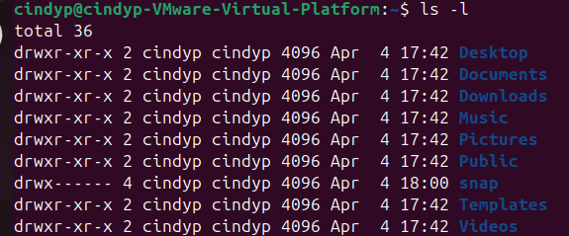
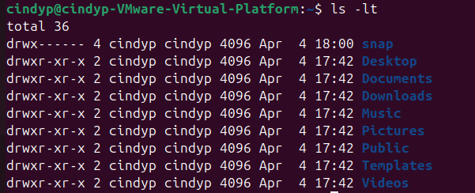

• How to check old commands that you recently used in the terminal. (Hint you can use UP Arrow to see the older commands type other command name with example)
To check and see old commands that were recently used in the terminal, you can use the UP arrow to see one by one previous commands. Another way to check previous commands is by using the history command line to check old commands.
SCREENSHOT BELOW:
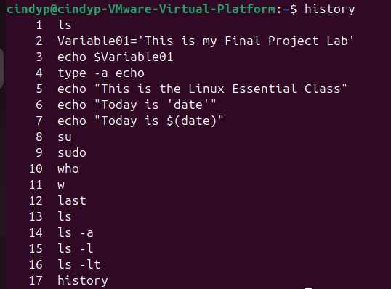
• What is variable and how we can use it use below command and SHARE THE SCREENSHOT of the results:
o fahad@fahad-VM: ~ $ Variable01=’This is my Final Project Lab’
o fahad@fahad-VM: ~ $ echo $Variable01
The variable command line in linux represents data and it is a placeholder or name for that data that can change. Variables can store and reuse values/data in scripts and shell sessions. We can use variables to automate tasks, manage system settings, and for scripting. The two types of variables in Linux are user defined variables and environmental variables. User defined variables are created and are assigned values. Environmental variables are system defined variables that store environment related information or can also store system settings.
SCREENSHOT:
Exercise # 2: Using Internal and External commands in Terminal
• Define Internal and external commands with examples.
Internal commands are a part of and built into the shell program. Internal commands are directly executed by the shell which means that internal commands do not require external files. Internal commands do not call on external binaries and internal commands are always available as long as the shell is available and running. Internal command examples include: cd, echo, history, pwd, and exit.
Contrary to internal commands, external commands are not part of the shell program. External commands are separate files that are located and stored in the system. External commands require an external binary or external file to execute. Compared to internal commands, external commands are more complex and offer more functionality. Examples of external commands are: ls commands, cat, cp, grep, and chmod. You can check whether a command is internal or external by using the type command line, or which command line for external commands. External commands are found in directories such as /bin, /usr/bin, or /sbin, etc.
• Explain the result of this command:
fahad@fahad-VM: ~ $ Type -a echo
RESULT:
echo is a shell builtin,
echo is /usr/bin/echo
echo is /bin/echo
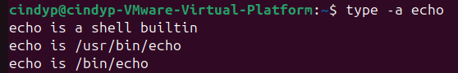
• What is double quoting?
Double quoting is the use of double quotation marks (“ “) around characters or a command. Double quoting allows the grouping of multiple words or characters as a single format. Double quoting allows spacing between words without errors. Unlike single quotes, Double quotes allow variable expansion and command substitution.
- write result of below command:
fahad@fahad-VM: ~ $ echo “This is the Linux Essential Class”
RESULT:

• What is a Single Quote?
Single quoting (‘ ‘) interprets everything inside the quotes literally, including special characters like backslashes. Single quotes do preserve spaces but do not expand variables or perform command substitutions. Single quotes are used to enclose strings and preserve the value of every literal character inside the single quotes. Everything inside single quotes is treated exactly as it’s typed.
• I want to write a command for below result:
o Echo The Car Cost $1000
• But result comes like this:
o The Car Cost 000
• How I can get my desired Result?
o The Car Cost $1000
The issue here and the reason why the desired result is failing is because the shell terminal interprets the dollar sign ($) as a variable. The dollar sign needs to be treated literally. The desired results can be achieved by using single quotes or escaping the dollar sign with a backslash. For example: echo 'The Car Cost $1000'.
Or also: echo "The Car Cost \$1000".
SCREENSHOT:
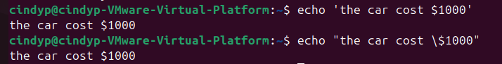

• How can we use backslash with single or double quotes? Write any example only.
echo "The Car Cost \$1000".
• Write the command echo Today is ‘date’ and share the result of this command. (TAKE A SCREENSHOT OF THE RESULT OF THIS COMMAND FOR PROJECT GRADING)
Exercise # 3: Working with Control Statements
In this exercise you will work on control statements.
• Define control statements and share some basic control statements with us. • Please share examples of Semicolon (;), Double Ampersand (&&) and Double Pipe (||).
Control statements control the flow of execution in terminal commands or shell scripts. Control statements allow you to execute commands based on repeated actions/looping statements, conditional statements, and control how the commands interact with each other. Control statements allow flexible scripts that can respond to different and various situations. The semicolon control statement separates multiple commands to execute sequentially. The double ampersand control statement depends on the success of the first command. The double ampersand control statement executes the second command if the first command succeeds. And finally, the double pipe control statement executes the second command line only if the first command fails. The double pipe control statement can be used when an alternative action is specified due to the first command failing to succeed.
- Semicolon control statement example: command1; command2; command3
Or to be more specific: echo "Starting task"; ls -l; echo "Task completed"
- Double Ampersand (&&) control statement example: command1 && command2
Or to be more specific: mkdir my_directory && cd my_directory && touch file.txt
- Double Pipe (||) control statement example: command1 || command2
Or to be more specific: mkdir my_directory || echo "Failed to create directory"

Deliverables of Task 3:
• Answer the questions and take screenshot of the result of the command in Exercise 1 • Answer the questions and take screenshot of the result of the command in Exercise 2 • Answer the 2 questions asked in Exercise # 3
Task # 4: Identifying User Accounts
In this task you will demonstrate basic understanding with users Accounts. Please answer the following questions and take screenshots where necessary.
• What is the Administrator Account?
The administrator account, or superuser, in Linux has root privileges. The administrator account performs administrative tasks and it can also manage other user accounts. The administrative account is able to install or remove software, change system configurations, and it can modify system files. Root users/administrative account users can execute any command without any restrictions. Root users can use sudo commands.
• What is meant by Switching Account?
Switching user accounts in Linux means changing accounts from one user account to the other all within the exact same session. In a professional setting, switching user accounts can be helpful for root/admin users when another user has an issuer accessing their files. The su command helps in switching between user accounts. The great thing about switching accounts in Linux is that you don't need to completely log out of the system and back in.
• What are System Accounts?
System accounts are accounts that do not represent human users. System accounts serve specific functions that are required by the system for proper operation and functions. System accounts are special user accounts that are used by the operating system. System user accounts are not regular user accounts and they have limited privilege access to the system. Also, system user accounts do not have associated login shells.
• What su – command does?
The su - command line is used to switch between user accounts. The su - command is normally used to switch to the root user.
(SHARE THE SCREENSHOT OF THE RESULT OF THIS COMMAND AS WELL)
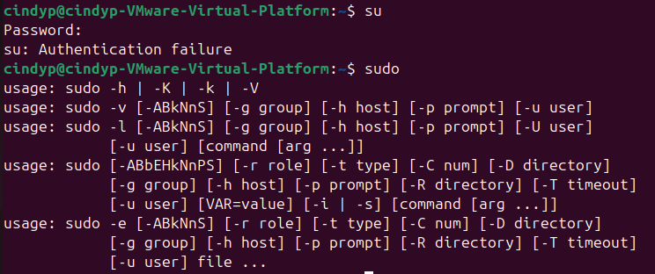
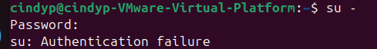
• Why do we use “who” command in Ubuntu? Please share the screenshot of the result of this command.
The who command line displays information about the users that are currently logged into the system. The who command line also provides details about the user such as login time, ip address, hostname, username, and terminal used. Who command line tracks user activity so this command is very useful for root/administrative accounts to monitor who is active within the system and to track the user’s activity. Active system sessions from users can be monitored using the who command.
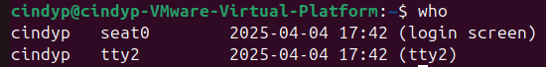
• Please explain the result if I type this in terminal:
o fahad@fahad-VM:~$ w (Type ‘w’ and press enter)
As you can see from the screenshot below, the w command provides detailed information about the current users that are logged into the system. It also provides information about the user’s usage and activity. Compared to the who command, it gives more information about the users that are currently logged in. It shows how long the user has been active. The w command monitors idle time, cpu usage, and checks who is logged in.
• Type below command and share the screenshot of the result and some explanation:
o fahad@fahad-VM:~$ last (Type ‘Last’ and press enter)
The last command line shows the history of users who logged in and logged out. It can also show system reboots. The last command line shows the most recently logged in users, so the sessions are in chronological order. TTY means the terminal in which the user logged in from. Remote logins show the ip address. The last command line also shows the duration of logged in users.
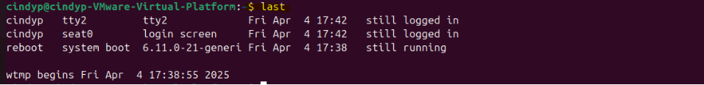

Project Submission:
Congrats! Your Project has been completed here, please compile all screenshots and answers to the questions in each task on a word document and upload it under the project submission section on your dashboard so that the mentor can provide grading.

